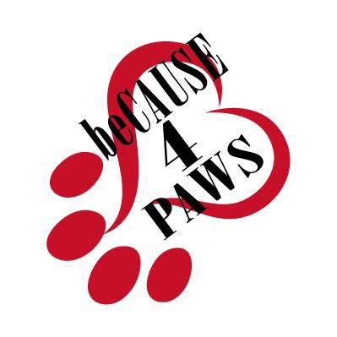
beCAUSE 4 PAWS, INC.
2 Old Park Lane Road
New Milford, CT 06776
860-799-6690
www.because4paws.org

CANINE
SPAY/NEUTER POST-OPERATIVE INSTRUCTIONS

DATE: __________________________

ANIMAL ___________________________________

PROCEDURE: ( ) Spay ( ) Neuter

Your pet has just undergone a complete orchiectomy/ovariohysterectomy. Although he/she may look and feel great we ask that you take the following precautions:

- Watch him/her and keep him/her from licking the incision (an e-collar may be used if necessary)
- Leash walk him/her for 10-14 days
- Keep his/her activity level down so that he/she is not excessively jumping and/or rough housing
- Do not bathe him/her or allow him/her to swim for at least 10-14 days
- Tonight, feed him/her half the meal he/she normally gets, then tomorrow he/she can resume his/her normal amount of food
- Tonight – do not let him/her take in large amounts of water. Tomorrow – he/she can resume normal amounts of water
- Do not allow him/her to scratch or lick the incision site (an e-collar may be used if necessary)
- Check the incision at least once daily for swelling, redness or discharge.

Occasionally, an animal may experience some postoperative complications including some of the following:

- Incisional discomfort. Do not administer any pain medication, other than that prescribed by your veterinarian, as detailed below.
- Depression. Call your regular veterinarian if it seems excessive.
- Vomiting or diarrhea. Call your regular veterinarian if this occurs.
- Incisional swelling or drainage. Call your regular veterinarian if this occurs.

Most dogs have absorbable sutures or glue that do not require removal.

Suture removal is needed: YES _______ NO _______

VACCINATIONS GIVEN:
DHPP _____ Boost in 3-4 weeks ______ 1 Year ______ 3 year

Rabies ______ BB______ 4DX Results______ Deworming______ Microchip______

MEDICATION INSTRUCTIONS: _ Give tab(lets) twice daily for days. Give with food. Start tonight.

Carprofen mg.

